**Home page**

*Desktop view*

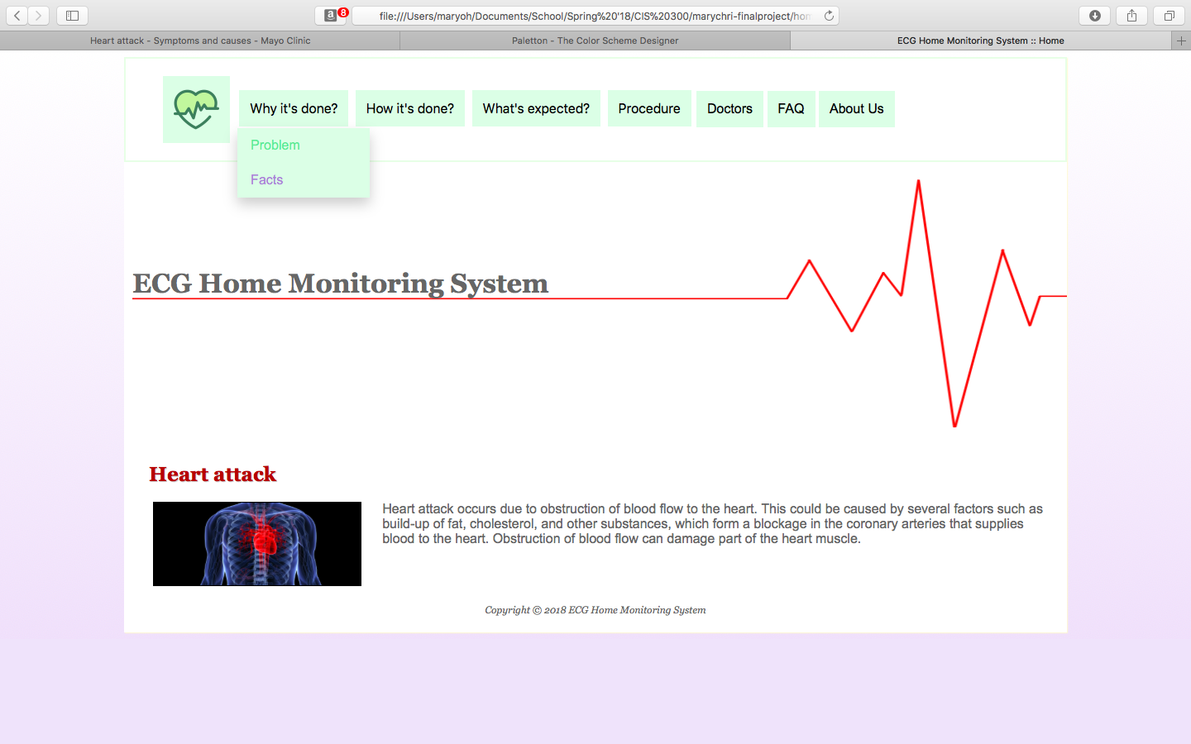

*Tablet view*

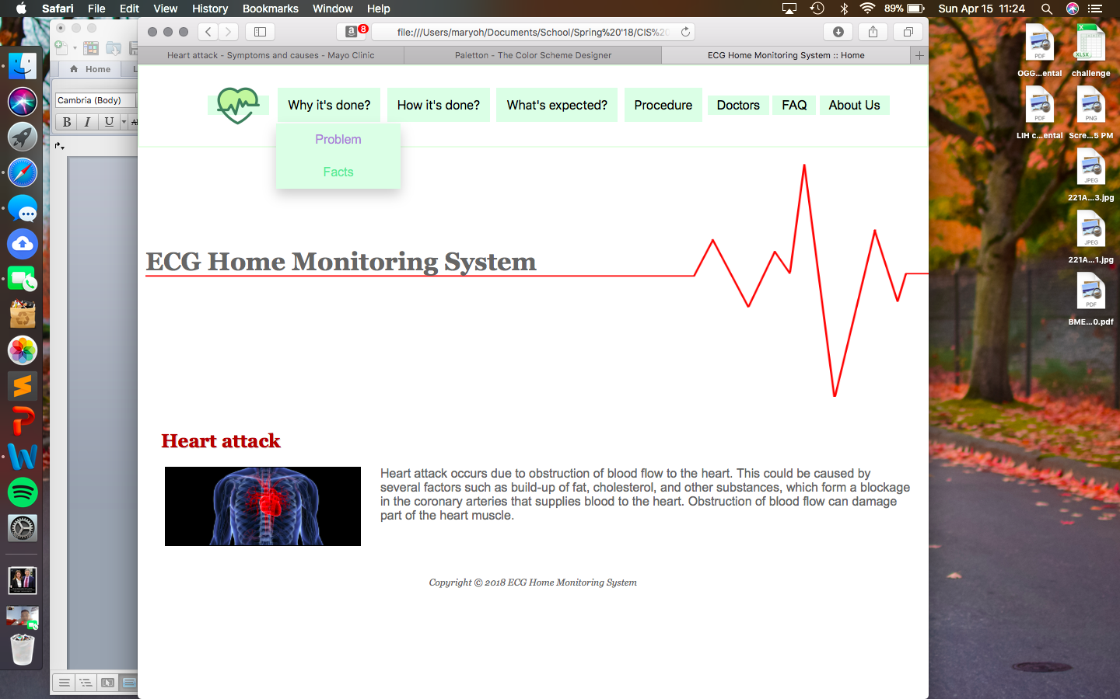

*Mobile view*

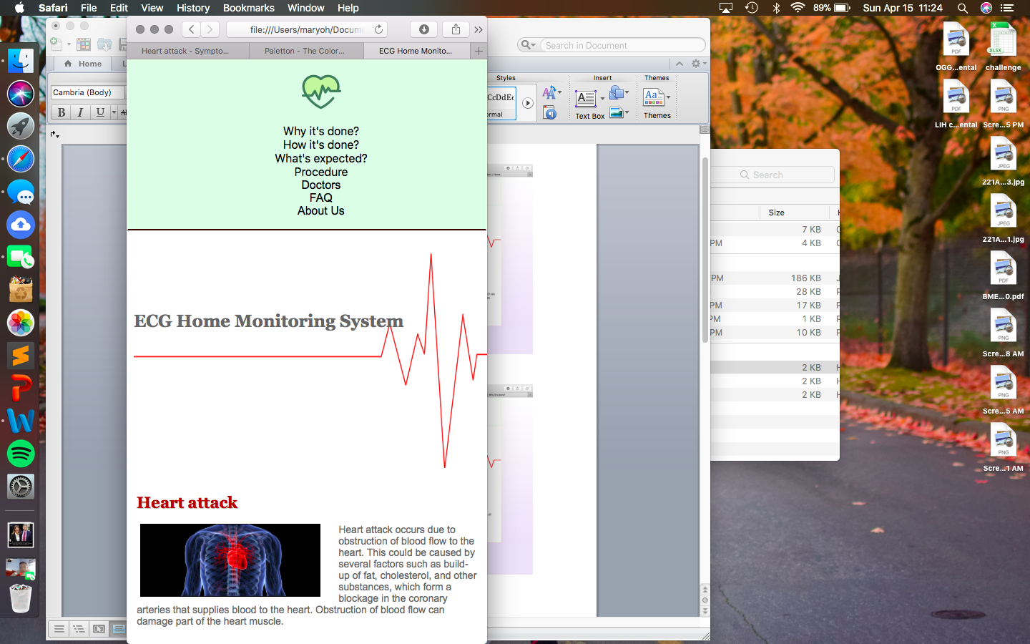

**Why it’s done? page**

*Desktop view*

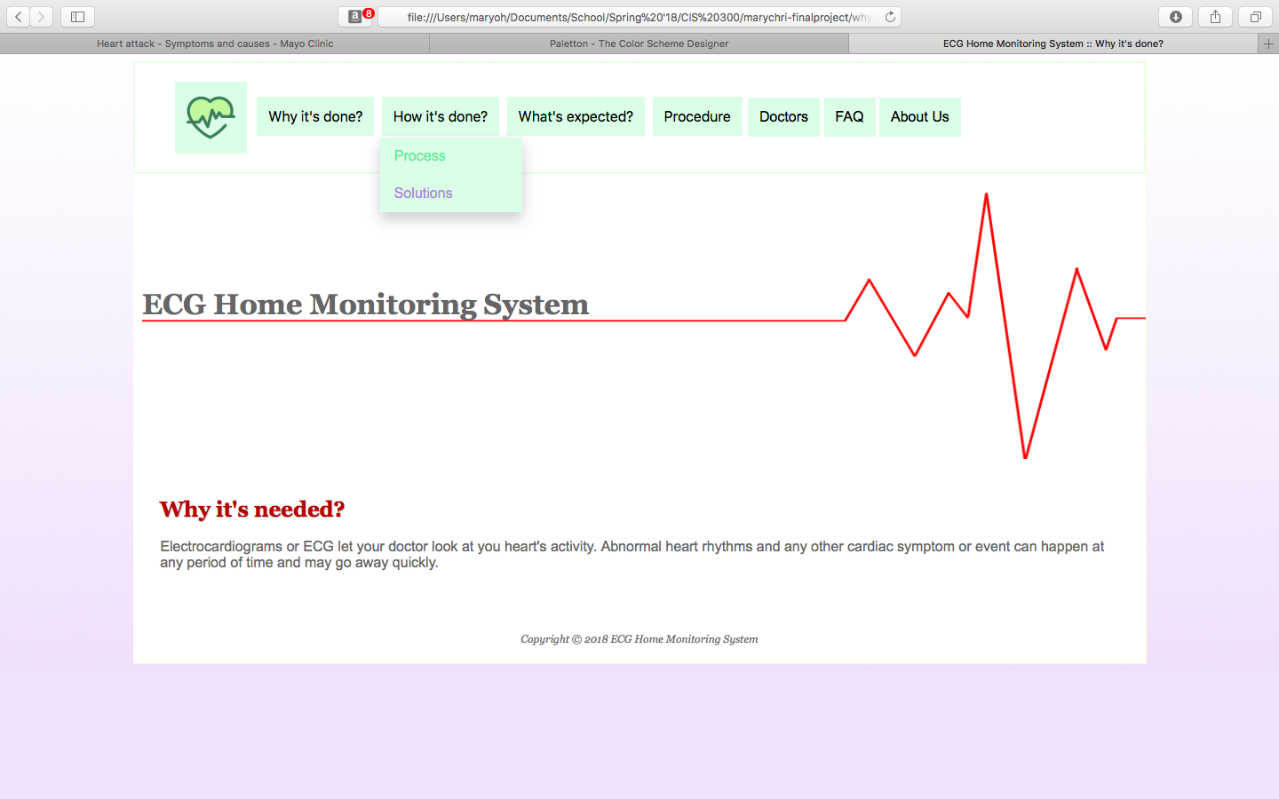

*Tablet view*

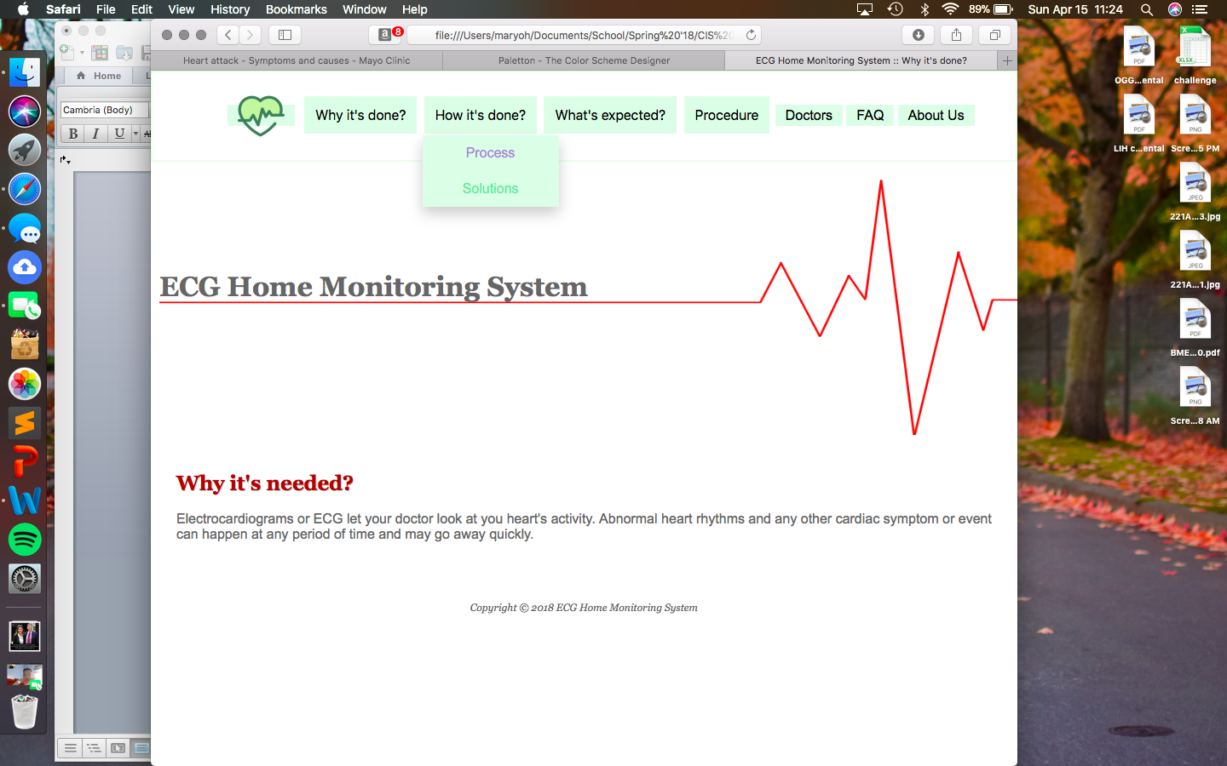

*Mobile view*

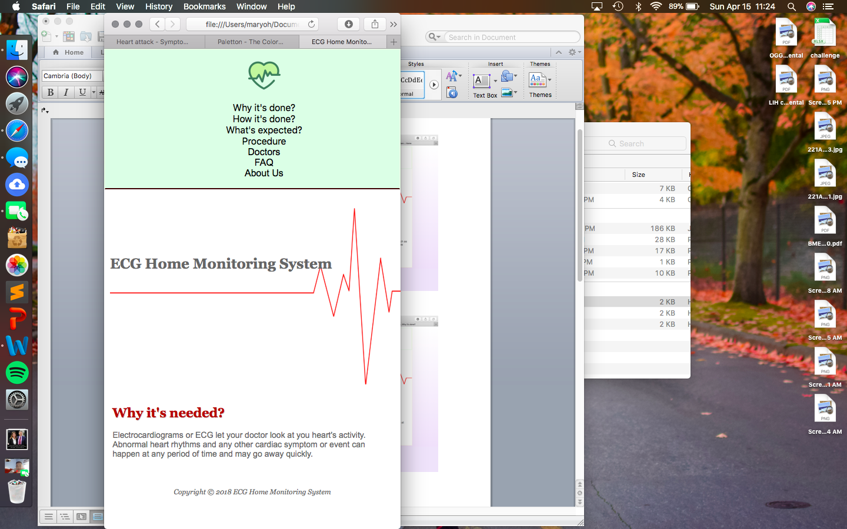

**How it’s done? page**

*Desktop view*

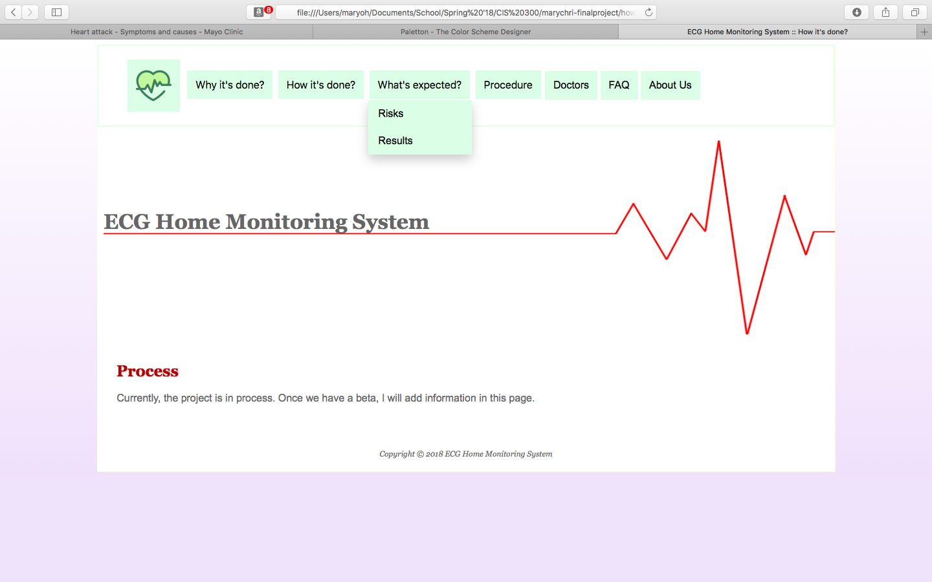

*Tablet view*

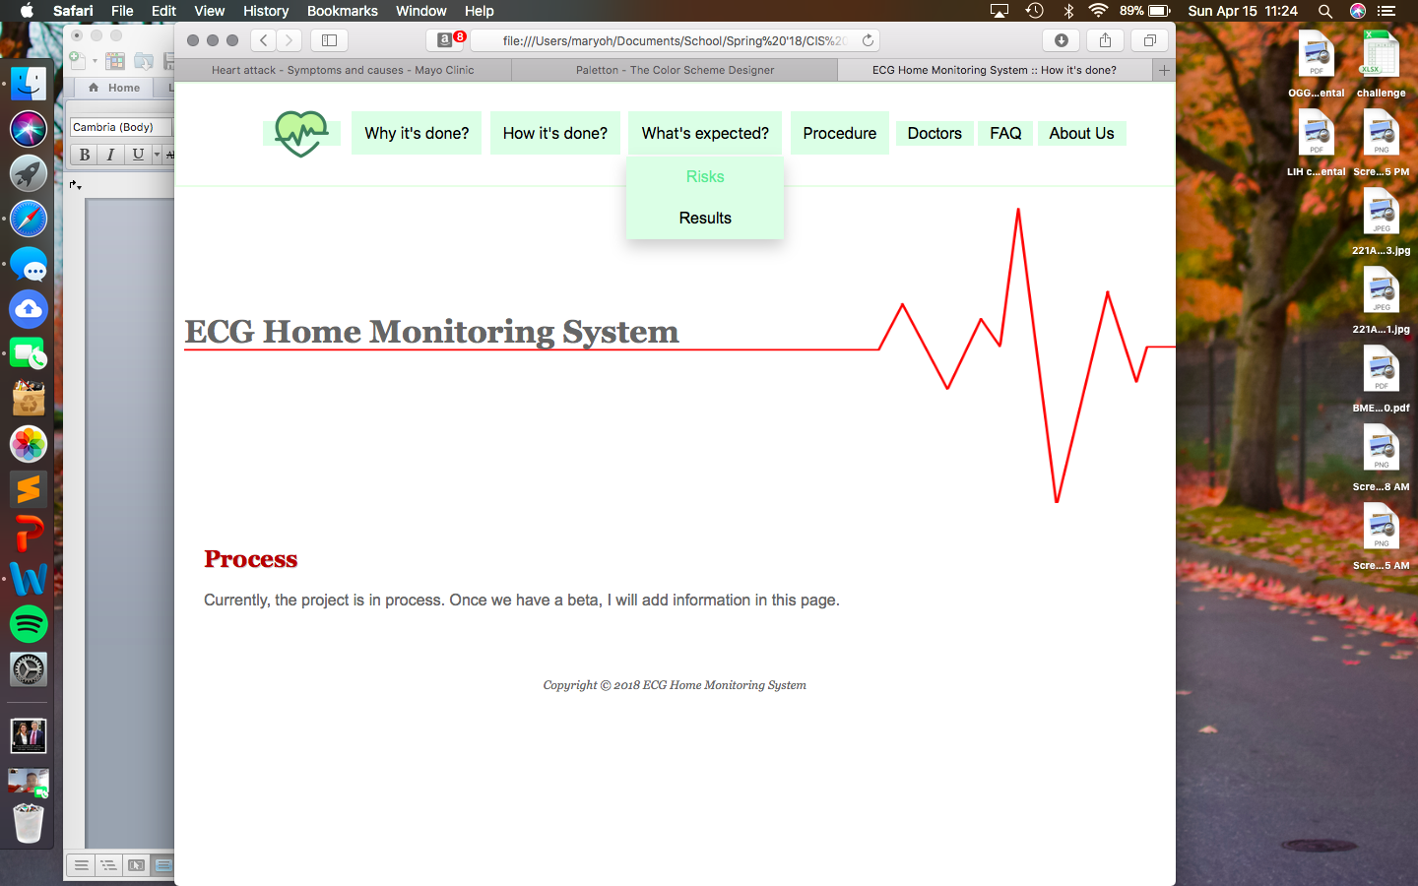

*Mobile view*

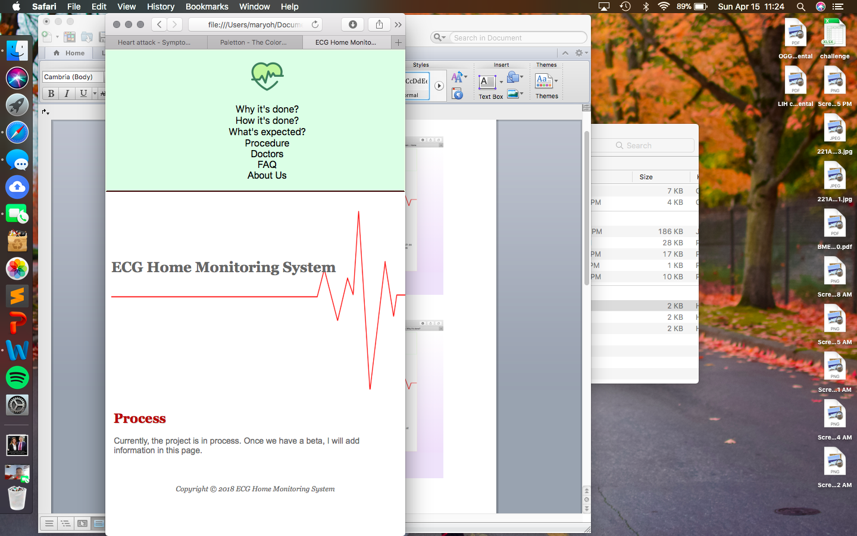

**What’s expected? page**

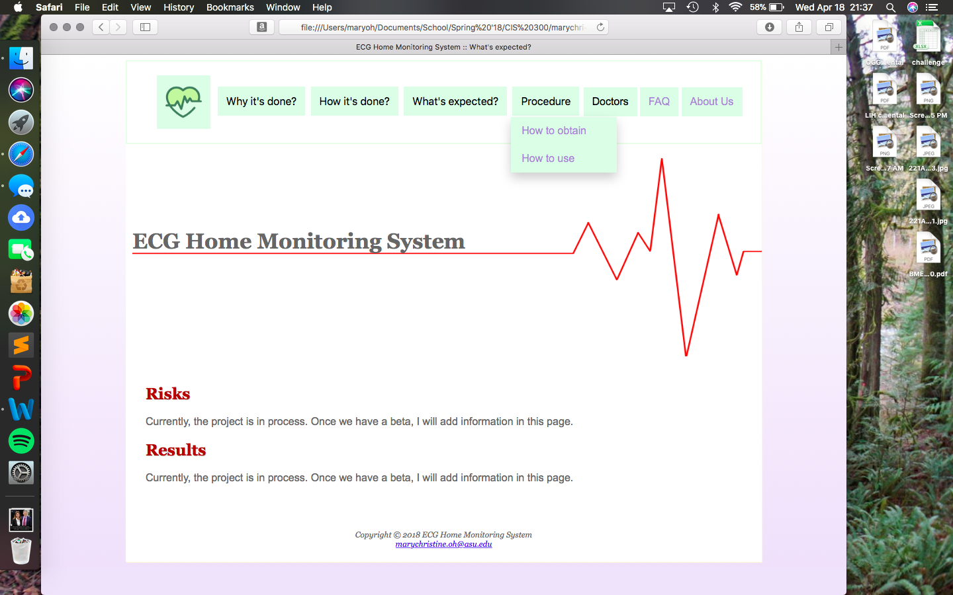

**Procedure page**

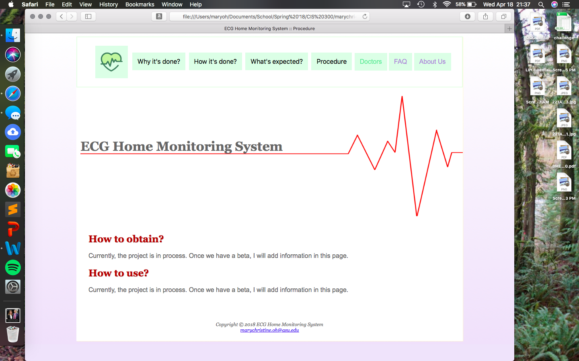

**FAQ page**

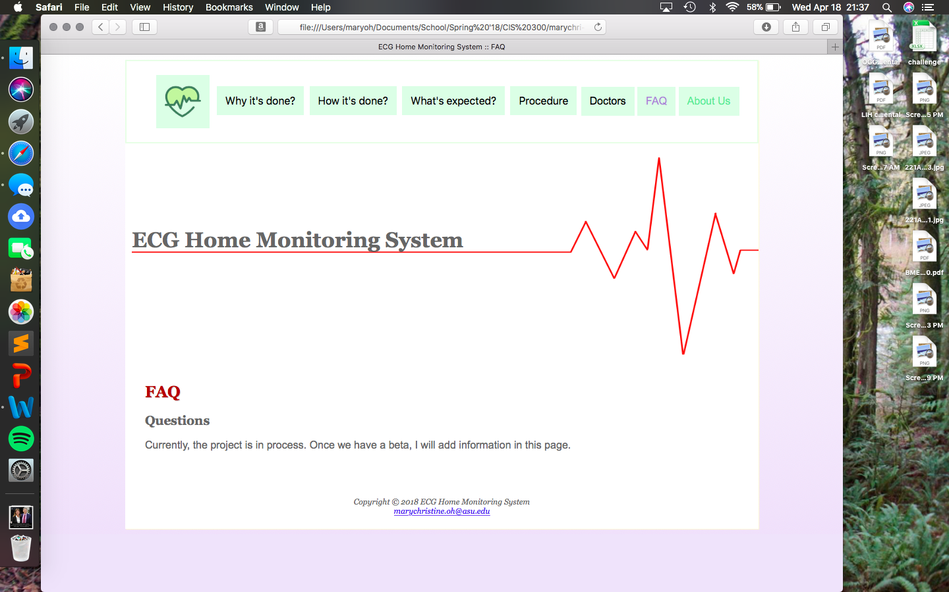

**About us page**

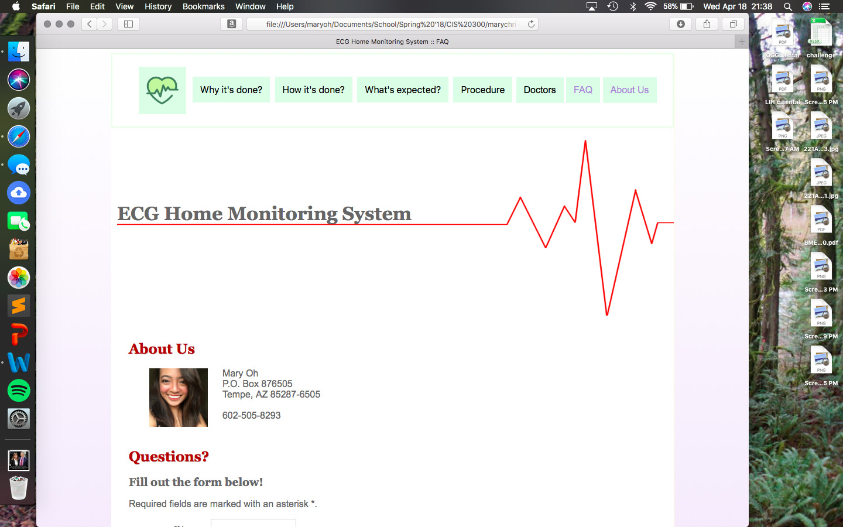

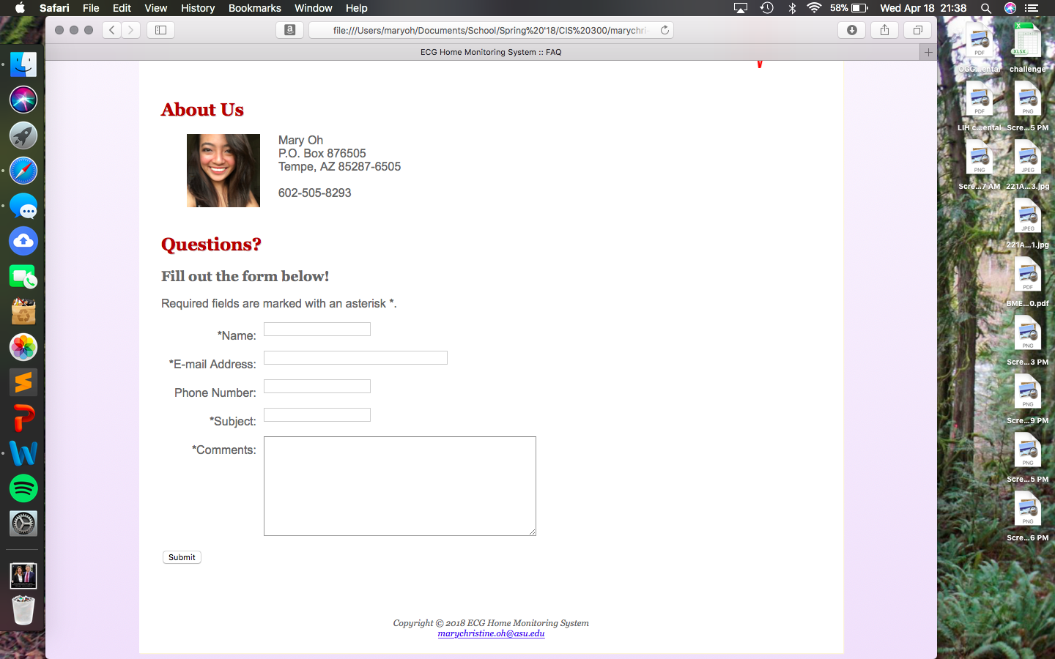

Since the project is still in progress, I really don’t have much information available yet. However, I should have more by next week as the parts for the project just got delivered and the beta will be started by this week.